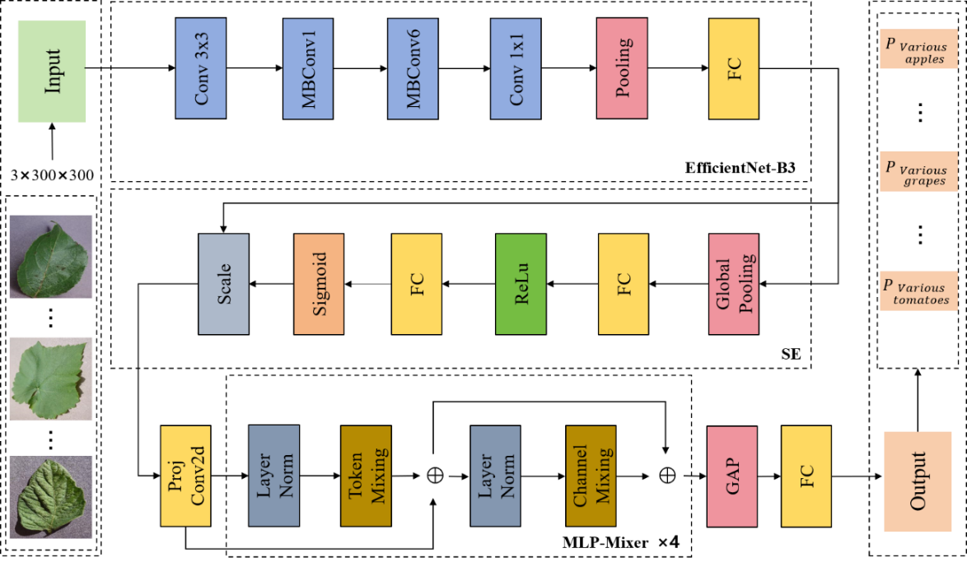
Figure 3.5 Overall framework of the proposed model

